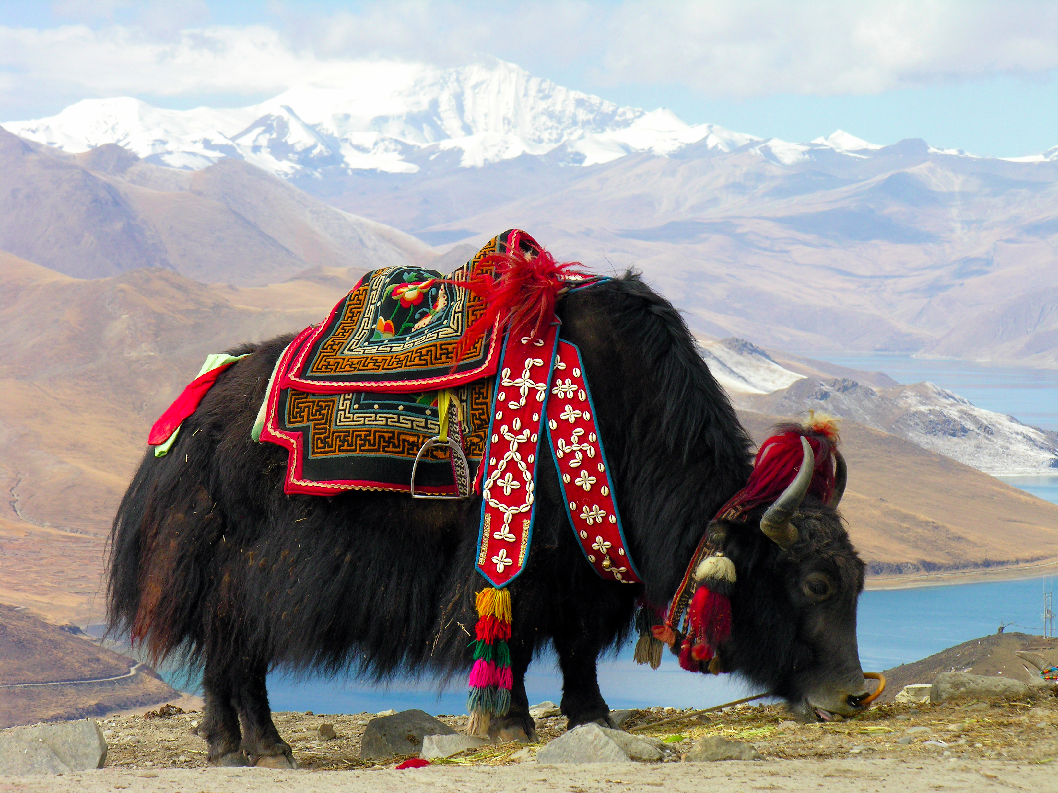
RAFT Assignment

Unit/Theme: Culture of Himalayan Region

Role | Audience | Format | Topic
Sherpa | Latin American urban citizen | Choose one:  - Series of letters, emails, tweets, etc.  - Alphaboxes with illustrations  - Tri-fold/Pamphlet | Himalayan Culture (Technology, Religion, Institutions, Beliefs & Customs, Language)
Rice Farmer or Villager | European urban citizen | Choose one:  - Series of letters, emails, tweets, etc.  - Alphaboxes with illustrations  - Tri-fold/Pamphlet | Himalayan Culture (Technology, Religion, Institutions, Beliefs & Customs, Language)
Lama/Buddhist Monk | North African/Middle Eastern citizen | Choose one:  - Series of letters, emails, tweets, etc.  - Alphaboxes with illustrations  - Tri-fold/Pamphlet | Himalayan Culture (Technology, Religion, Institutions, Beliefs & Customs, Language)

